**Stage View / Blue Ocean View**

**Stage View**

* **Classic Visualization**:  
  Stage View is part of the standard Jenkins interface. It provides a visual representation of your pipeline’s execution, breaking it down into individual stages (as defined in your Jenkinsfile).
* **Key Features**:
  + **Stage Breakdown**: Each defined stage in your pipeline (e.g., Build, Test, Deploy) is shown as a segment in the view.
  + **Real-time Status**: You can see at a glance which stages have succeeded, which are in progress, and which have failed.
  + **Logs and Details**: Clicking on a stage often lets you see logs and more detailed output from that particular stage.
* **Usage**:  
  It’s useful for teams who want a quick, high-level look at their pipeline’s progress without additional bells and whistles.

**Blue Ocean**

* **Modern UI**:  
  Blue Ocean is a modern, reimagined user interface for Jenkins. It aims to provide a more intuitive, visually appealing, and user-friendly experience.
* **Key Features**:
  + **Enhanced Pipeline Visualization**:  
    Blue Ocean displays your pipeline as a flow diagram, where each stage is represented in a visually engaging way. This can make it easier to understand the overall process and spot where issues may be occurring.
  + **Improved Navigation**:  
    It offers a streamlined interface with better navigation and filtering options, which can be especially useful for large and complex pipelines.
  + **Integrated Feedback**:  
    Blue Ocean not only shows the status of each stage but also integrates real-time feedback, making it easier to drill down into details such as logs, test results, and more.
* **Installation and Use**:  
  Blue Ocean is provided as a plugin. If it’s not already installed on your Jenkins instance, you’ll need to add it via the Jenkins Plugin Manager.

# For stage view and blue ocean, we have to install plugins.

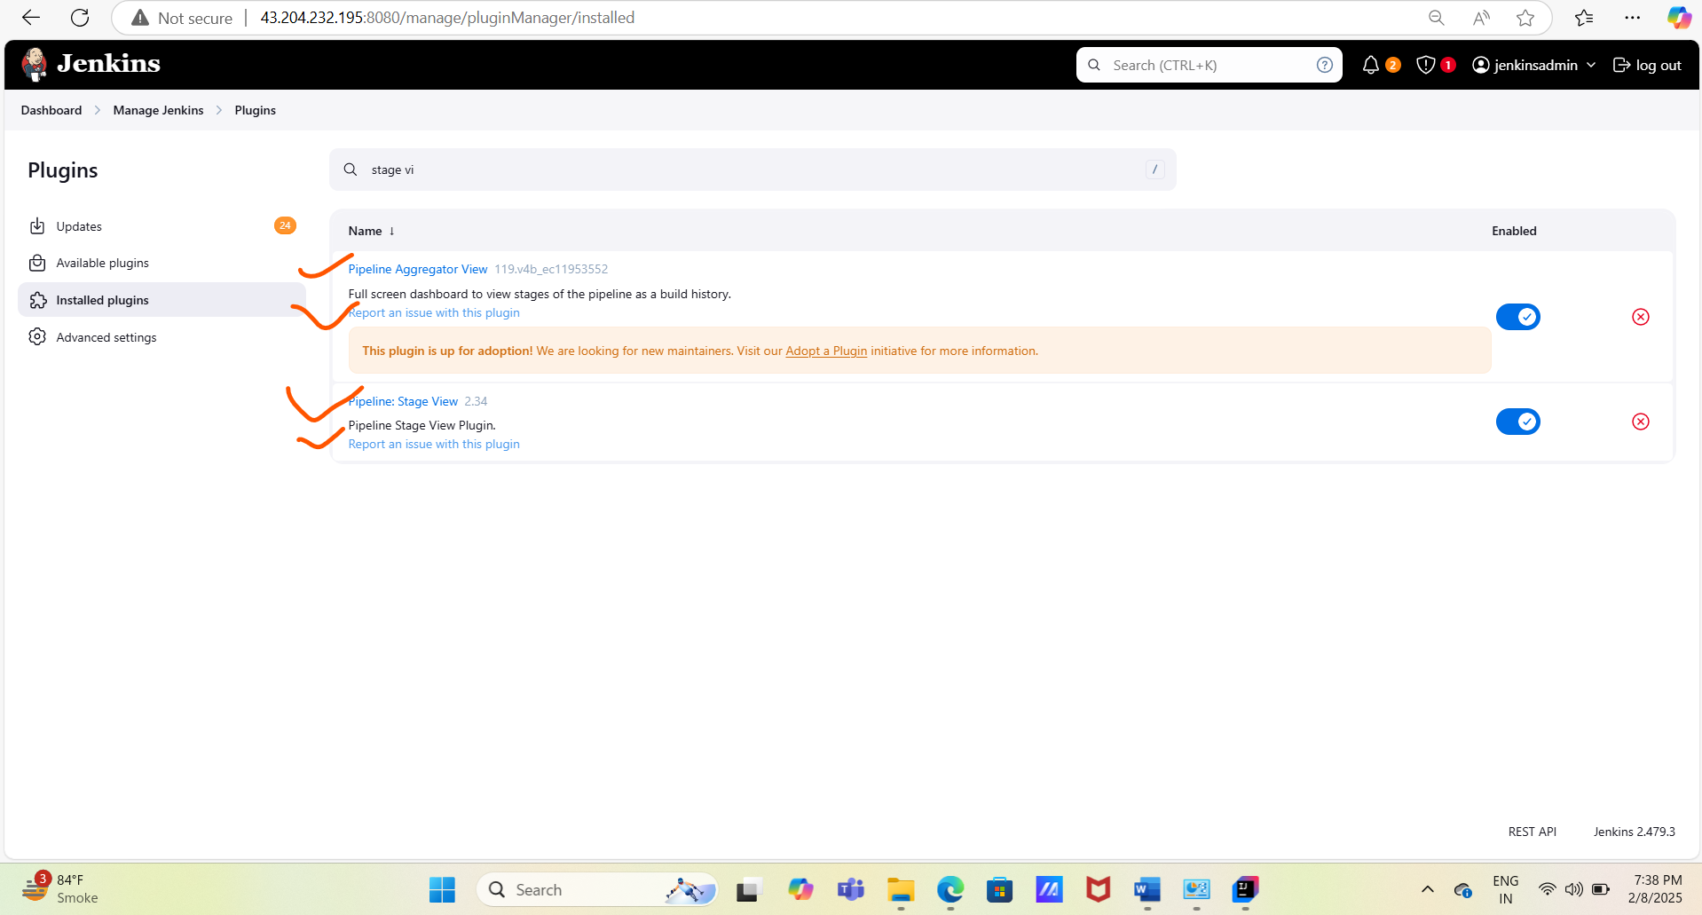

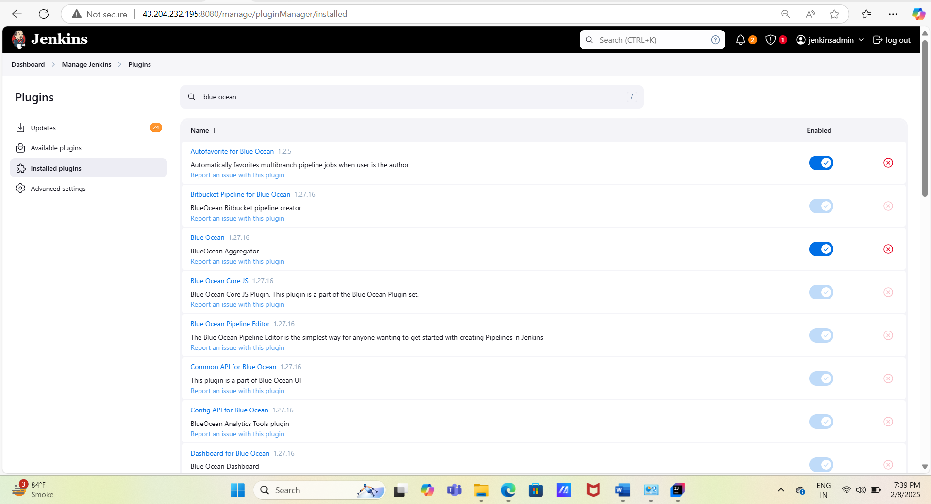

#Working and use of stage view

The Stage View is primarily used for monitoring the status of running pipelines.

With monitoring plugins, you can inspect the various stages executed during a Jenkins job.

These stages are defined within the Jenkinsfile, which is included in the microservice.

This setup helps users easily track job statuses and view job logs.

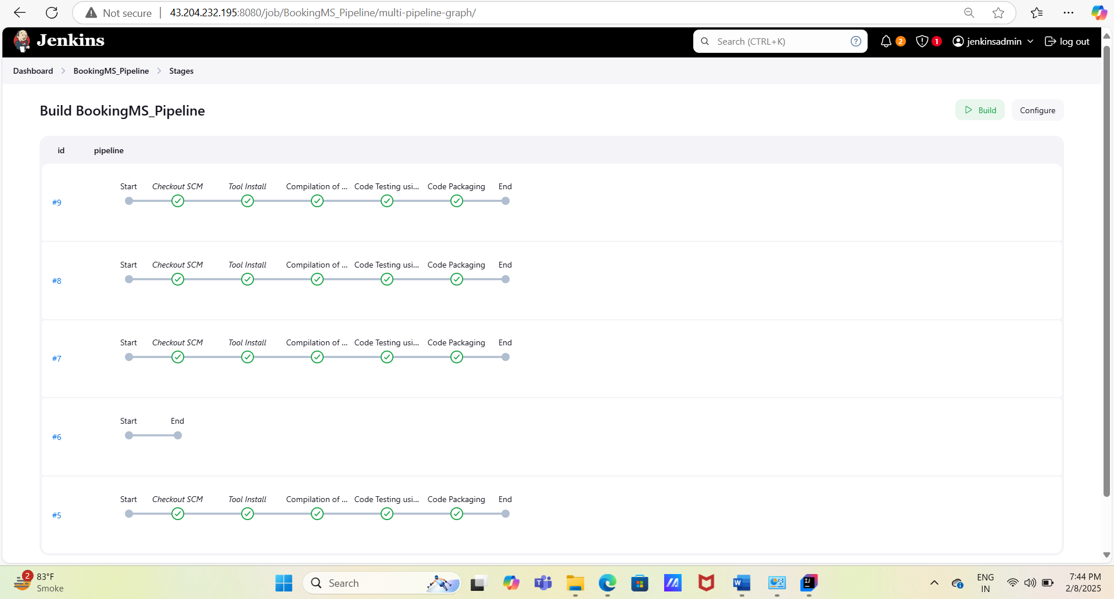

#Working and use of blue ocean view

Blue Ocean is an enhanced version of Stage View.

It provides a more advanced and user-friendly way to view pipeline job stages compared to the standard Stage View.

Using Blue Ocean, you can access detailed job information directly on the UI, such as:

* **Status**
* **Run**
* **Commit**
* **Message**
* **Duration**
* **Completion**

It offers a comprehensive view that helps users understand the entire job process through its advanced monitoring interface.

Additionally, Blue Ocean allows you to rerun or restart code packaging directly from the UI.

It also enables users to view logs for each stage and examine changes or artifacts directly on the interface.

